**Importance of making presentation**

* Extremely important in one’s professional career
* Turning point in many cases
* Best opportunity to show people and to show how smart you ar.

**Rule of thumb**

-know your audience and don’t overestimate their capabilities to comprehend your presentation.

* -Assume responsibility of delivery
* -Prepare, prepare, prepare

Advices in Presentation

* Use powerpoint whenever possible
* Both audio and visual channels of communications and more information transfer in the same amount of time.
* The slides serves as an automatic reminder of things in the correct order
* Preparing the slides forces you to organize and rehearse your talk and helps you uncover weak spots
* Last minute change if possible
* Synchronizing with sound recording and presenting without physical presence.
* Use multiple slides or the animation feature to control the display of information on your slides.
* Never make a slide too crowded.

-No busy slide

-copying text from your thesis is totally unacceptable

-The minimal size for text is 18 POINTS , and occasionally in graphics 14 points can be used. Very rarely in detail graphs you can use 12 points.

* Provide a road map and use it via the device of a summary slide below:

Topic 1

.

.

Topic I

.

.

Topic N

To highlight sub-topical matters, I , under discussion

* Never change notations half way through a talk by copying those in another talk to save efforts
* When using graphic notation , make the graphics distinct and use it repeatedly
* Use one consistent name or label to denote one thing
* Don’t use too many variables throughout.
* Always define things , your problem statement, mathematical symbols and your goals , etc.
* Report reproducible experimental results with , I.e conditions defined , procedures outlined , and conclusions stated, and label your diagram and axes in graphs.
* Do not over use animation and graphics
* Don’t be self-centered . What is interesting to you may not hold the same interest for the audience.
* Control of talk time: no more than 15 SLIDES FOR 30 MINUTES TALK for beginner.
* Take 15 minutes per slide in preparation and about 30 minutes per slide with graphics. One hour-talk == 7.5 hours in front of a computer.

Organization of Slides

Title

Arrange text and graphs appropriately: **example**

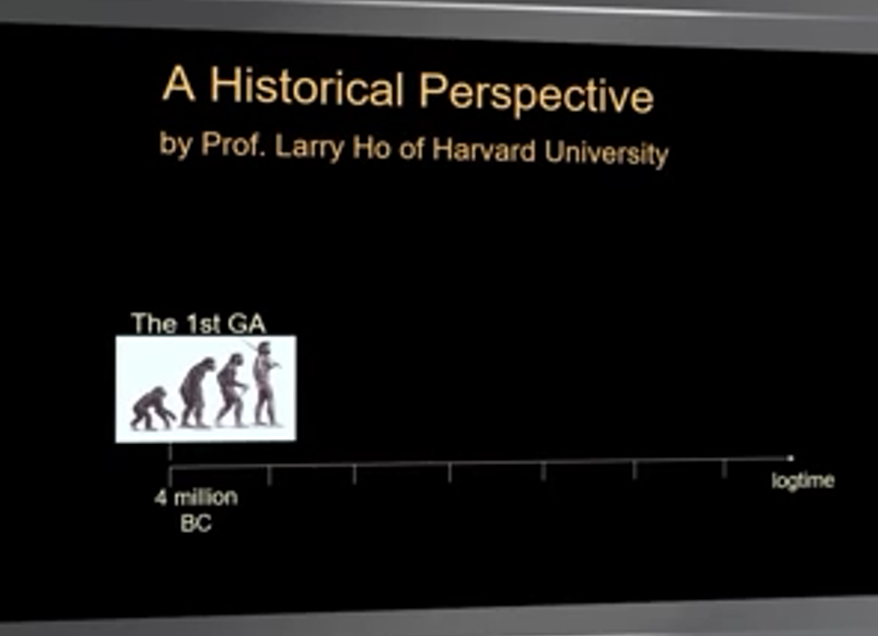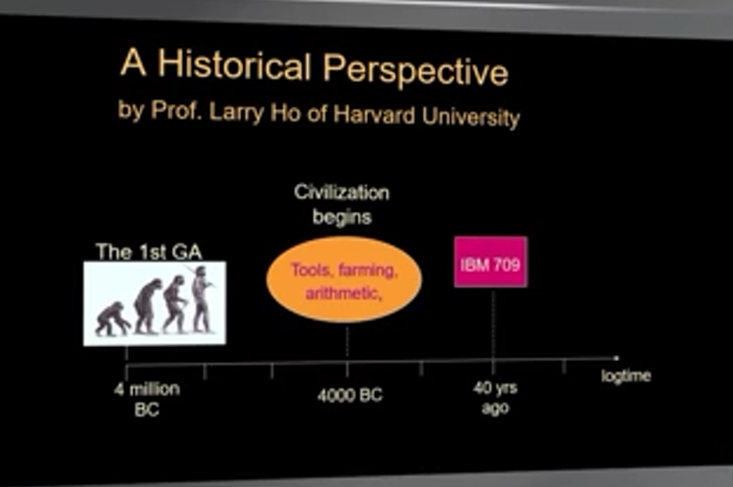

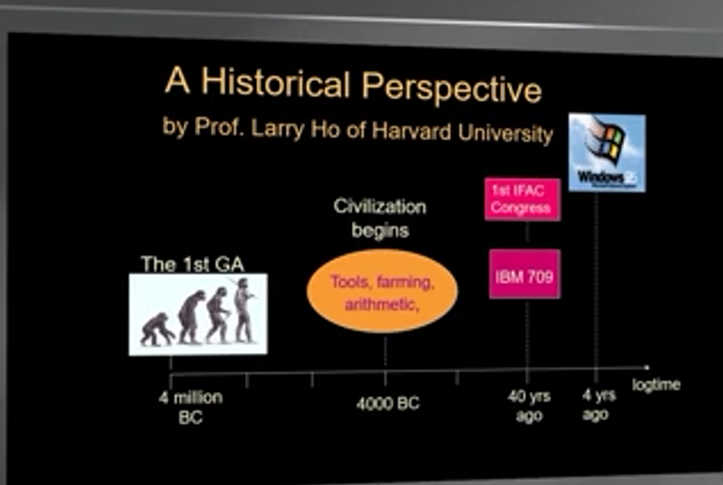

**Instructions of making presentations**

* Don’t read but present with confidence
* Mention main goal early to capture the attention
* Try to vary emphasis
* Don’t slur your pronunciations and let sentences trail off
* Watch where you stand when you speak. Don’t cover up the screen for some of the audience
* Don’t keep the laser pointer on all the time . use it only when you need it.
* Watch your hand gestures . Don’t keep them in your pocket
* Record your talk and review it.

**Questions Ask and Answer**

* Ask and Answer questions politely
* Listen very carefully and make every effort to understand the question correctly.
* Deflect the answer to the point you want to emphasize for irrelevant questions.
* Admit and/or offer the approach to finding the answer. Or offer answers later if no answer
* Prepare slides for expected questions
* Take the questions in the rehearsal as pre-views.

SUMMARY

* Making presentations in English is extremely important for scholars
* It is entirely possible for non-native speakers to make excellent presentation in English
* Practice is the only way to achieve the above goal.